Upper Deverills Parish Council

9 Beech Grove, Warminster, Wiltshire, BA12 0AB Tel: 01985 213436
Chairman: Miss Louise Stratton Clerk Mrs Sarah Jeffries MILCM

All Parish Council Meetings are open to the Public and Press
Wednesday 27th April 2016 6.30pm

To All Members of the Upper Deverills Parish Council
Dear Councillor,

You are summoned to an extraordinary meeting of the Upper Deverills Parish Council, at Kingston Deverill Village Hall on Wednesday 27th April 2016 6.30pm. The meeting will consider the items set out below.
Before the meeting there will be a public session to enable the people of the Upper Deverills to ask questions of, and make comments, regarding the Parish Council. Questions not answered at this meeting will be answered in writing to the person asking the question, or may appear as an agenda item for the next meeting. Members of the public are asked to restrict their comments, and/or questions to three minutes.
Sarah Jeffries MILCM 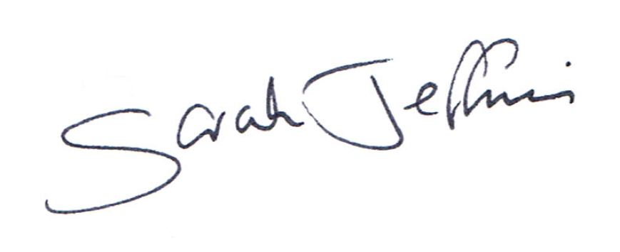 19th April 2016
Parish Clerk

6.30pm Public Question Time
This section (at the Chairman’s discretion may last up to 15 minutes) is not part of the formal meeting of the Council and minutes will not be produced.

1. Acceptance of apologies for absence
Schedule 12 of the Local Government Act 1972 requires a record to be kept of the members present and that this record form part of the minutes of the meeting. Members who cannot attend a meeting should tender apologies to the Parish Clerk as it is usual for the grounds upon which apologies are tendered also to be recorded. Under Section 85(1) of the Local Government Act1972, members present must decide whether the reason(s) for a member's absence are accepted.

2. Chairman’s announcements

3. Dispensations
Council is asked to discuss any written requests for dispensation the Clerk may have received from Councillors. Council is asked to resolve the dispensations if required.

4. Declarations of interest, members to declare any interest they may have in agenda items that accord with the requirements of the relevant authorities (Disclosable Pecuniary Interests) Regulation 2012 (SI 2012/1464) (NB this does not preclude any later declarations)

5. Exclusion of the Press and Public Standing Order #1c The Parish Council may exercise their right to exclude the public and press by resolution from a closed meeting due to the confidential nature to be discussed pursuant to section 1(2) of the Public Bodies (Admission to Meetings) Act 1960.

6. To receive and sign the minutes of the Full Council meeting held on the 9th March 2016 (Previously circulated) LGA 1972 Sch 12 para 41(1)

7. Planning Application No 16/00327/FUL
Proposal: Erection of two dwellings and associated external works.
Location: Whitepits Kingston Deverill Warminster BA12 7HD
Council is asked to discuss the above application and inform the Clerk of its decision.

8. Notification of planning application decision to appeal – barn adjacent to 81 Hindon road, Monkton Deverill
Council is asked to confirm receipt of the below correspondence.

Reference: Planning Application and re-submission of 15/06445/FUL Barn adjacent to 81 Hindon Road, Monkton Deverill, Warminster BA12 7EXi. In accordance with National Planning Policy Framework (NPPF) ii & iii, and continuing our 14 months attempting at transparent communication with the Monkton Deverill parishioners, and the Upper Deverills Parish Council, regarding our aspirations to develop the adjacent barn into a family home; you might wish to note that we have decided to refer the Wiltshire Council decision to the Planning Inspectorate.

9. TOWN AND COUNTRY PLANNING ACT 1990
Council is asked to discuss the below correspondence from Wiltshire Council and inform the clerk of its decision.

I am writing to let you know that an appeal has been made to the Planning Inspectorate in respect of the above site.
The appeal is against a refusal in respect of the above site, and is to be decided on the basis of Written Representations procedure.
If you wish you are now able to make written comments on the proposal. These should be sent in triplicate direct to the Planning Inspectorate, Room 3/10b Kite Wing, 2 The Square, Temple Quay House. Bristol BS1 6PN, quoting the Inspectorate reference, and should be received within 5 weeks of the start date above. Alternatively, you can sent comments via email to Ct2@pins.gsi.gov.uk
Any representations received after the deadline will not normally be seen by the Inspector and will be returned.
Any comments you may have already made following the original application will also be forwarded to the Inspectorate (unless they are expressly confidential) but you may withdraw, modify or amplify them now if you wish. All comments received will be copied to the appellant and will be taken into account by the Inspector in deciding the appeal.
If you wish to receive a copy of the appeal Decision Letter, you should write to the Planning Inspectorate specifically requesting one.
The Planning Inspectorate will not acknowledge your letter unless you specifically ask them to do so. They will, however, ensure that your letter is passed on to the Inspector dealing with the appeal.
The Planning Inspectorate have introduced an online appeals service which you can use to comment on this appeal. You can find the service through the Appeals area of the Planning Portal – see www.planningportal.gov.uk/pcs. The Inspectorate may publish details of your comments, on the internet (on the appeals area of the planning portal). Your comments may include your name, address, email address or phone number, please ensure that you only provide information, including personal information belonging to you that you are happy will be made available to others in this way. If you supply information, belonging to a third party please ensure you have their permission to do so. More detailed information about data protection and privacy matters is available on the Planning Portal.

Finally, you may wish to note that The Planning Inspectorate has produced a guide to taking part in planning appeals. If you would like to receive a copy of this, please contact me on the telephone number set out at the head of this letter, further information can also be obtained from their web site at www.planning-inspectorate.gov.uk

10. Parish Clerks Delegated Powers the Clerk will give Council details of any matters dealt with under her delegated powers since the last meeting of Council. LGA 1972 s101

11. Notice of items to be taken into consideration at the next meeting.
Councillors are asked to highlight items.

12. Items for Parish Newsletter & Notice Boards
Councillors are asked to inform the Clerk.

13. Date of the next meeting The Council is asked to note that Wednesday 11th May 2016 is the date of the next Full Council meeting.

Council are asked to note that in the exercise of their functions they must take note of the following: Equal opportunities (race, gender, sexual orientation, marital status and any disability); Crime and Disorder, Health and Safety and Human Rights. Any person who may find difficulty in access to the meeting through disability is asked to advise the Clerk (07540 611906) or 01985 213436 email (upperdeverills@virginmedia.com) at least 24 hours before the meeting so that every effort may be made to provide access

Chairman: Louise Stratton Slades Cottage Kingston Deverill, Warminster Wiltshire BA12 7HE
Clerk: Mrs Sarah Jeffries MILCM 9 Beech Grove Warminster

